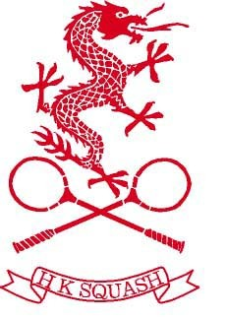 Cathay Pacific Sun Hung Kai Financial Hong Kong Squash Open 2014 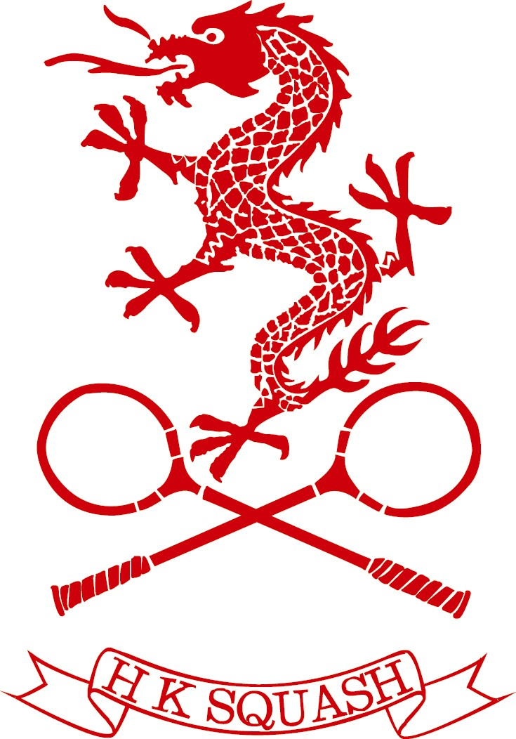 Prime Seats (back wall)
T | x | x | x | 4 | 5 | 6 | 7 | 8 | 9 | 10 | 11 | 12 | 13 | 14 | 15 | 16 | 17 | 18 | x | x | x
S |  |  |  | 4 | 5 | 6 | 7 | 8 | 9 | 10 | 11 | 12 | 13 | 14 | 15 | 16 | 17 | 18
R |  |  |  | 4 | 5 | 6 | 7 | 8 | 9 | 10 | 11 | 12 | 13 | 14 | 15 | 16 | 17 | 18
Q |  |  |  | 4 | 5 | 6 | 7 | 8 | 9 | 10 | 11 | 12 | 13 | 14 | 15 | 16 | 17 | 18
P |  |  |  | 4 | 5 | 6 | 7 | 8 | 9 | 10 | 11 | 12 | 13 | 14 | 15 | 16 | 17 | 18
O | AISLE STEPS |  |  | 4 | 5 | 6 | 7 | 8 | 9 | 10 | 11 | 12 | 13 | 14 | 15 | 16 | 17 | 18 | AISLE STEPS
N |  |  |  | 4 | 5 | 6 | 7 | 8 | 9 | 10 | 11 | 12 | 13 | 14 | 15 | 16 | 17 | 18
M |  |  |  | 4 | 5 | 6 | 7 | 8 | 9 | 10 | 11 | 12 | 13 | 14 | 15 | 16 | 17 | 18
L |  |  |  | 4 | 5 | 6 | 7 | 8 | 9 | 10 | 11 | 12 | 13 | 14 | 15 | 16 | 17 | 18
K |  |  |  | 4 | 5 | 6 | 7 | 8 | 9 | 10 | 11 | 12 | 13 | 14 | 15 | 16 | 17 | 18
J |  |  |  | 4 | 5 | 6 | 7 | 8 | 9 | 10 | 11 | 12 | 13 | 14 | 15 | 16 | 17 | 18
I |  |  |  | 4 | 5 | 6 | 7 | 8 | 9 | 10 | 11 | 12 | 13 | 14 | 15 | 16 | 17 | 18
H |  |  |  | 4 | 5 | 6 | 7 | 8 | 9 | 10 | 11 | 12 | 13 | 14 | 15 | 16 | 17 | 18
G |  |  |  | 4 | 5 | 6 | 7 | 8 | 9 | 10 | 11 | 12 | 13 | 14 | 15 | 16 | 17 | 18
F |  |  |  | 4 | 5 | 6 | 7 | 8 | 9 | 10 | 11 | 12 | 13 | 14 | 15 | 16 | 17 | 18
E |  |  |  | 4 | 5 | 6 | 7 | 8 | 9 | 10 | 11 | 12 | 13 | 14 | 15 | 16 | 17 | 18
D |  |  |  | 4 | 5 | 6 | 7 | 8 | 9 | 10 | 11 | 12 | 13 | 14 | 15 | 16 | 17 | 18
C |  |  |  | 25 | 26 | 27 | 28 | 29  RESERVED | 30 | 31 | 32 | 33 | 34 | 35 | 36 | 37 | 38 | 39
B |  |  |  | 25 | 26 | 27 | 28 | 29 | 30 | 31 | 32 | 33 | 34 | 35 | 36 | 37 | 38 | 39
A |  |  |  | 25 | 26 | 27 | 28 | 29 | 30 | 31 | 32 | 33 | 34 | 35 | 36 | 37 | 38 | 39

ALL-GLASS SQUASH COURT
General Seat
General Seat

